Grazioso Salvare Dashboard README
Khem Khatiwada
Southern New Hampshire University
CS-340-18343-M01 Client/Server Development
Jeffrey Scranton
04/16/2026

Grazioso Salvare Dashboard README
Project Overview
This project involved creating a full-stack dashboard application for Grazioso Salvare, an international animal rescue training company. The purpose of the dashboard is to help users identify dogs from the Austin Animal Center Outcomes dataset that may be strong candidates for specialized rescue training. The application uses MongoDB as the database model, a reusable Python CRUD module as the database interface, and the Dash framework to provide the web-based user interface. The finished dashboard allows users to filter animal data by rescue category, view the records in an interactive data table, and analyze the results through dynamic visualizations. This README documents the project functionality, tools used, implementation steps, challenges encountered, and instructions for reproducing the dashboard.
Required Functionality
The dashboard was developed to meet the project requirements described by Grazioso Salvare. The completed application includes the Grazioso Salvare logo, a unique identifier with my name, interactive filtering controls, a dynamic data table, a geolocation chart, and a second chart that updates based on the selected data. The dashboard supports four main filter states: Water Rescue, Mountain or Wilderness Rescue, Disaster or Individual Tracking, and Reset. The Reset option returns the dashboard to its original unfiltered state. The dashboard design helps reduce user errors and makes the system more intuitive for client use.
Starting Dashboard State
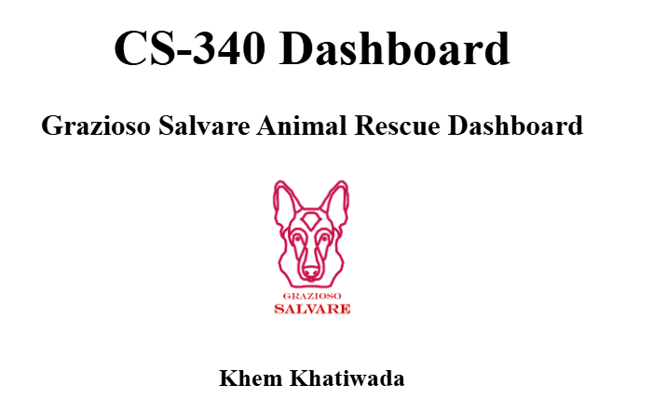
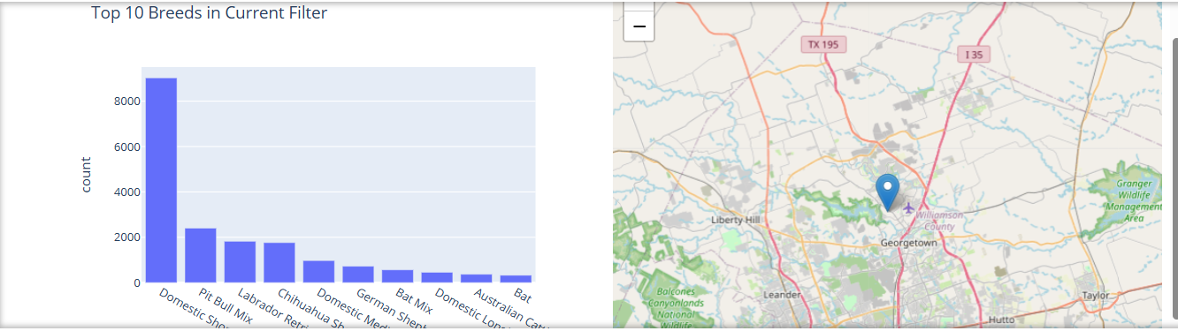
Figure 1. Starting state of the dashboard showing the rescue filter controls, interactive data table, geolocation map, second chart, Grazioso Salvare logo, and unique identifier.

Water Rescue Filter
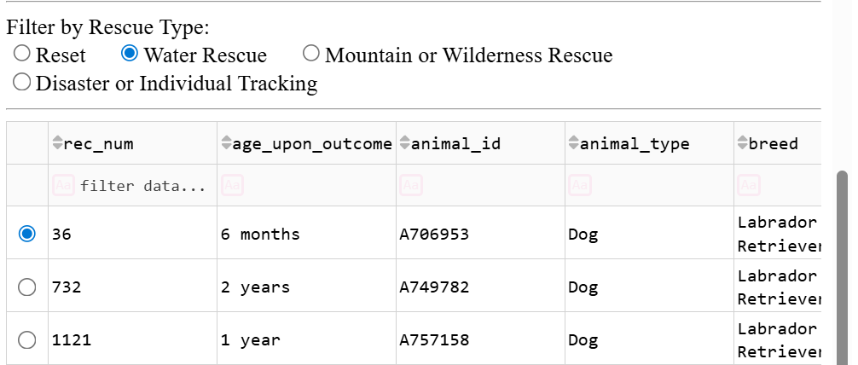
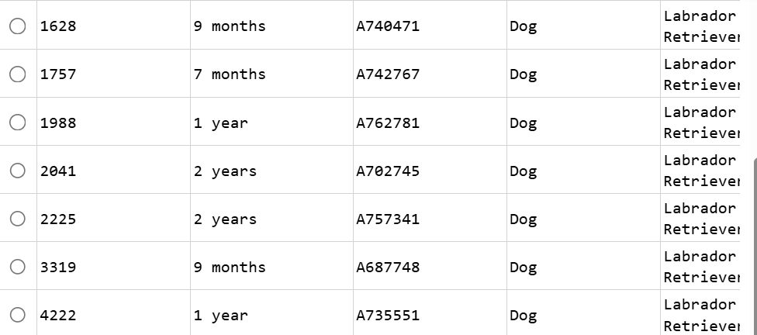
Figure 2. Dashboard after applying the Water Rescue filter, showing only dogs that match the water rescue criteria.

Mountain or Wilderness Rescue Filter
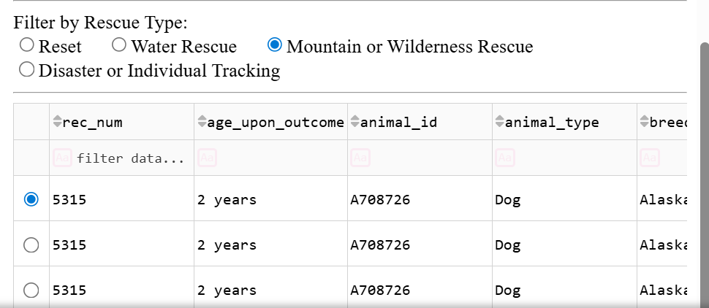
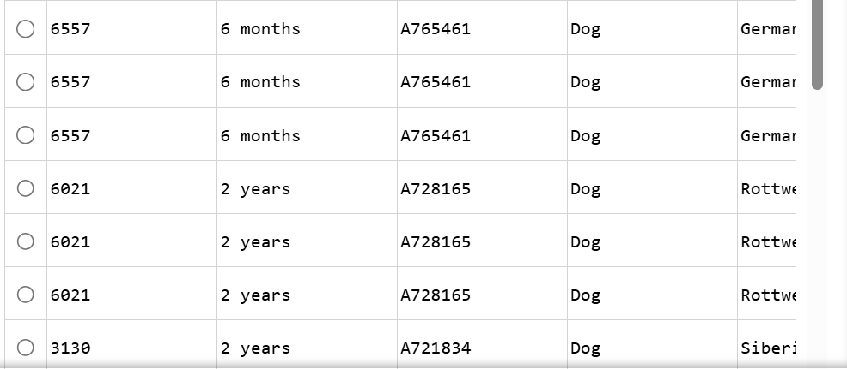
Figure 3. Dashboard after applying the Mountain or Wilderness Rescue filter, showing only dogs that match the wilderness rescue criteria.

Disaster or Individual Tracking Filter
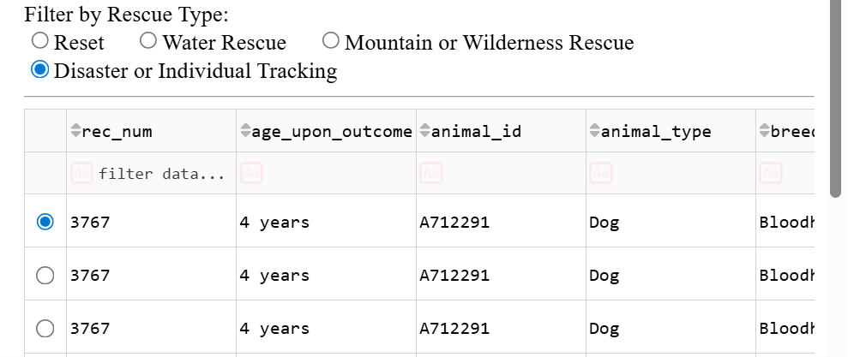
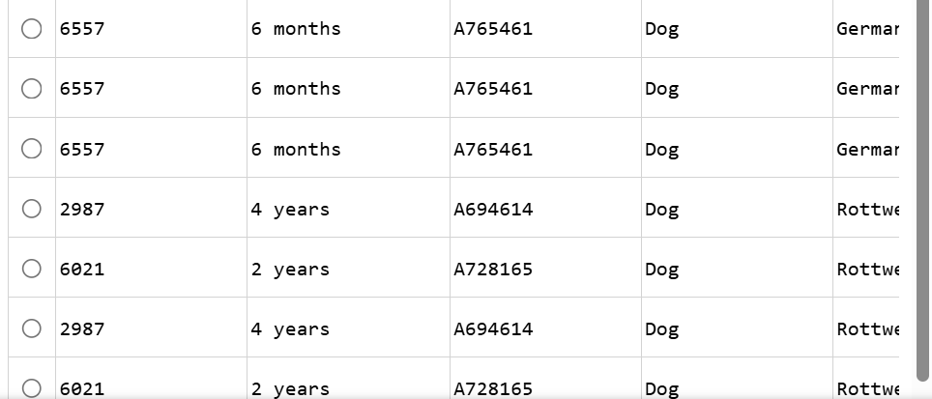
Figure 4. Dashboard after applying the Disaster or Individual Tracking filter, showing only dogs that match the tracking-related criteria.

Reset Filter
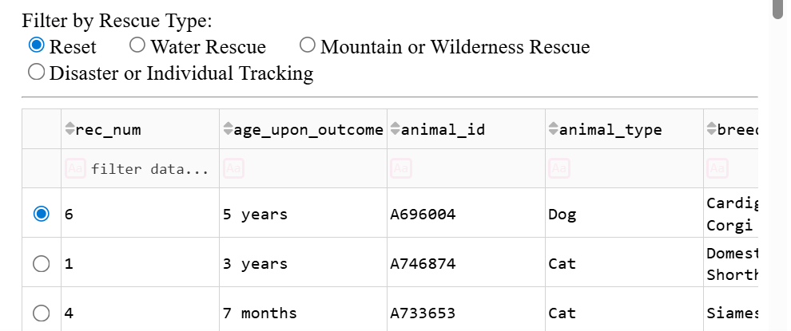
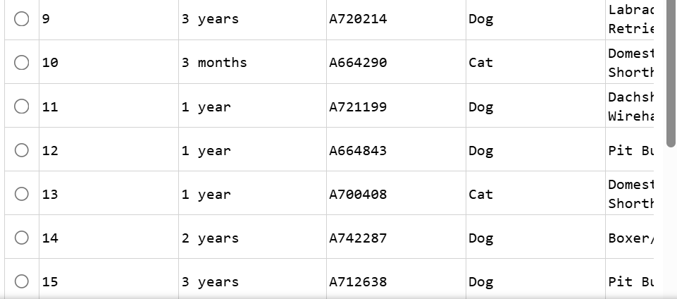
Figure 5. Dashboard after selecting Reset, returning all dashboard widgets to the original unfiltered state
Tools Used and Rationale
Several tools were used to complete this project. MongoDB was used as the database because it stores data in a flexible document format and works well with Python for data retrieval and filtering. Python was used because it provides strong support for object-oriented programming, database access, and dashboard development. The reusable CRUD module created in Project One served as the interface between the dashboard and MongoDB. Dash was used as the application framework because it allows developers to build interactive web applications entirely in Python. Plotly was used to generate the geolocation map and the second chart. Pandas was used to convert MongoDB query results into data frames for display in the dashboard table and visualizations. Jupyter Notebook in Codio was used to develop, test, and run the dashboard in the course environment.
Why MongoDB Was Used as the Model
MongoDB serves as the model component of the MVC design pattern used in this project. It is well-suited for this application because it stores animal shelter records as flexible JSON-like documents, making it easy to manage structured and semi-structured data. MongoDB also integrates well with Python via the pymongo library, enabling the application to efficiently submit queries and retrieve records. This flexibility is helpful in a rescue-animal dashboard because the application needs to filter records by breed, age, sex, animal type, and location. MongoDB’s document-based structure made it easier to work with these fields and dynamically return data to the dashboard.
Why Dash Was Used for the View and Controller
Dash provides both the view and controller structure for the web application. It supports interactive user interface components such as radio buttons, tables, and charts, while also allowing Python callback functions to control how the dashboard responds to user selections. This made Dash an effective choice because it allowed the interface and application logic to be built in a single Python environment. As a result, the dashboard could retrieve filtered records from MongoDB, display them in a data table, and automatically update the map and chart when the user selected a rescue type. This direct connection between interface widgets and callback logic made the application more efficient to develop and test.
Links to Resources and Software Applications
MongoDB: https://www.mongodb.com/
PyMongo Documentation: https://pymongo.readthedocs.io/
Dash Documentation: https://dash.plotly.com/
Plotly Python Documentation: https://plotly.com/python/
Pandas Documentation: https://pandas.pydata.org/docs/
Jupyter Documentation: https://jupyter.org/
Austin Animal Center Outcomes Dataset Reference: https://doi.org/10.26000/025.000001
Steps Taken to Complete the Project
The first step in the project was to reuse the CRUD Python module developed in Project One to enable the application to communicate with the MongoDB aac.animals collection. After that, the Austin Animal Center Outcomes data was retrieved from MongoDB and loaded into a Pandas DataFrame for display on the dashboard. The dashboard layout was then created in the notebook using Dash components, including the Grazioso Salvare logo, dashboard title, my unique identifier, filter controls, an interactive data table, and two charts.
Next, MongoDB queries were built for each rescue category. These queries filtered the data based on dog breed, age range, animal type, and intact status. The interactive options were implemented using Dash radio buttons, allowing the user to select a rescue category or reset the dashboard. Callback functions were then implemented to update the data table, geolocation chart, and second chart whenever the selected filter changed. Finally, the dashboard was tested by running the notebook, applying each filter option, and capturing screenshots of the resulting output for documentation in the README.
Challenges Encountered and How They Were Overcome
One challenge in this project was connecting the MongoDB data to the dashboard in a clean and reusable way. This issue was addressed by using the CRUD Python module from Project One, which provided a separate and organized interface for database queries. Another challenge was ensuring that the dashboard widgets updated dynamically and stayed synchronized when a new filter was selected. This was solved by using Dash callback functions that automatically refreshed the data table and charts based on the current filter selection.
A third challenge involved handling records with missing fields, such as missing latitude or longitude coordinates for the geolocation chart. This problem was addressed by removing records with missing coordinate values before generating the map. In addition, formatting the data for the Dash table required removing MongoDB’s internal _id field to make the table easier to read for users. These solutions improved both the functionality and usability of the complete dashboard.
Instructions for Reproducing the Project
To reproduce this project, begin by opening the Codio environment and launching Jupyter Notebook. Make sure MongoDB is running and that the Austin Animal Center Outcomes dataset has already been imported into the aac database and animals’ collection. Place the ProjectTwoDashboard.ipynb notebook, the AnimalShelter.py CRUD module, and the Grazioso Salvare logo image in the same working directory.
Next, open the notebook and verify that the MongoDB username and password in the code match the credentials created earlier for the aacuser account. Run all notebook cells in order. Once the app loads, use the radio button controls to test each rescue category filter: Water Rescue, Mountain or Wilderness Rescue, Disaster or Individual Tracking, and Reset. Confirm that the data table, geolocation chart, and second chart all update correctly. Capture screenshots of the dashboard in the starting state and after each required filter selection. Finally, save the notebook and place it alongside the CRUD module in a folder, compress the folder into a ZIP file, and submit it along with this README document.
Conclusion
This project successfully produced a functional dashboard for Grazioso Salvare that connects to MongoDB data and provides a web-based user interface. The final application allows users to identify rescue dog candidates more efficiently by filtering data, reviewing records in a table, and visualizing results through interactive charts. The use of MongoDB, Python, and Dash created a practical full-stack solution that met the client’s dashboard requirements and provided a foundation for future expansion.

